TC-VER-002
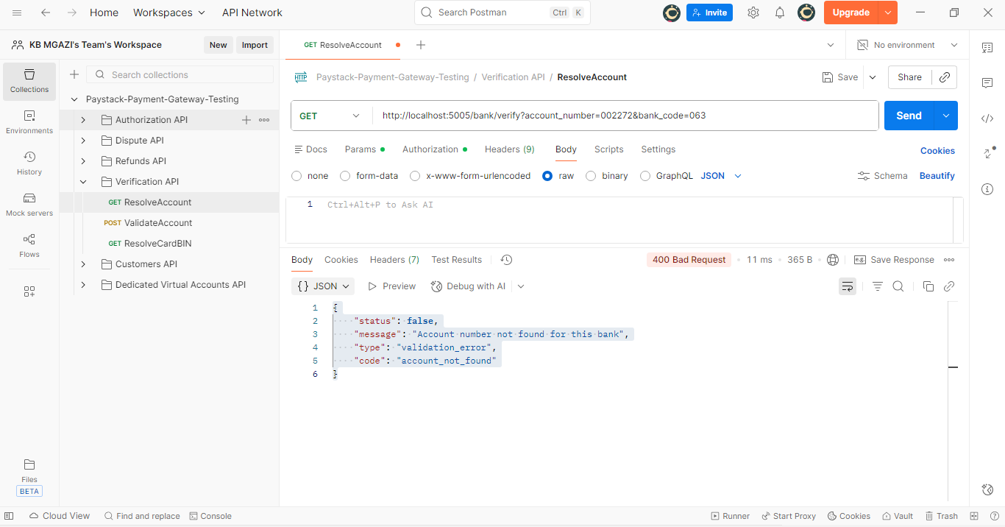
Response:
{
"status": false,
"message": "Account number not found for this bank",
"type": "validation_error",
"code": "account_not_found"
}

